NEWS RELEASE: The DEEP-SEA project comes to an end and the key achievements will be presented at the Final Event in Trieste, Italy, on 23rd November 2022.
Trieste, Italy, 18/11/2022.
On 23rd November, Trieste will gather Italian and Croatian stakeholders of the nautical and mobility sector to present the results of the DEEP-SEA project, a cross-border initiative started in January 2019 and co-financed by the European Regional Development Fund through the Interreg Italy-Croatia Programme. The project, led by ARIES Chamber of Commerce Venezia Giulia, involved 9 partners: the Chamber of Commerce of Foggia, the RERA agency for the coordination and development of the Split-Dalmatian County, the Province of Foggia, the three Universities of Trieste, Rijeka and Split, the Province of Foggia. On the island of Krk. Further partners have been the Municipality of Malinska Dubašnica and the public utility Ponikve Krk (on the island of Krk) and marina Martinis Marchi (island of Šolta). Through the development of a model, based on strong scientific knowledge and tested on field, the project supported Marinas Operators and local Public Authorities in planning and implementing sustainable mobility solutions across the two shores of the Adriatic Sea. Five pilot sites (in the province of Foggia and in the Venezia Giulia, in the Municipalities of Maslinica Dubašnica and Krk, Martinis Marchi marina in Šolta) were selected for the tailor-made investment plans in order to test the start-up of the new services and installations. They consisted of:
- 19 e-charging stations (power of 22 kWh or more, with interoperable management system) for e-cars and/or e-boats;
- 8 racks with electric and muscular bicycles for bike sharing services, including a charging system for e-bikes and software for rental;
- 3 e-scooters for sharing services and 1 e-car sharing for passengers transport;
- Start-up of e-car sharing services in 3 pilot sites;
- Start-up of 1 e-scooter sharing in Krk island;
- Start-up of 1 e-car mobility service for tourist transport in Maslinica Šolta;
- Micro-grid systems in 4 sites, made of: photovoltaic system; electrical storage system; monitoring and power management systems, display; connection to the electrical grid.
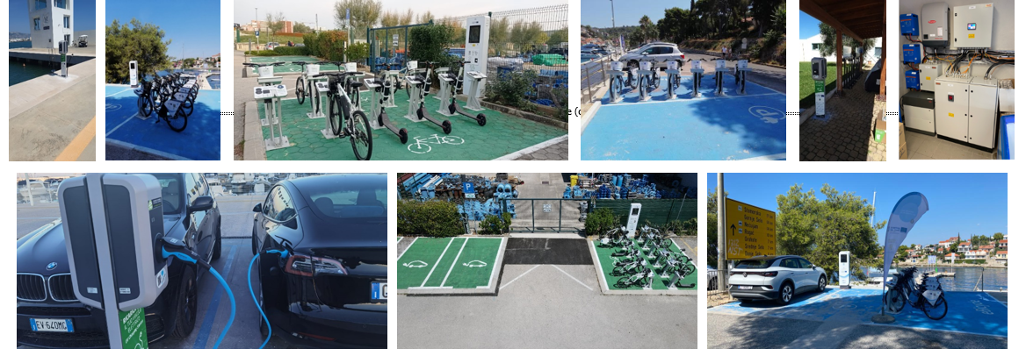
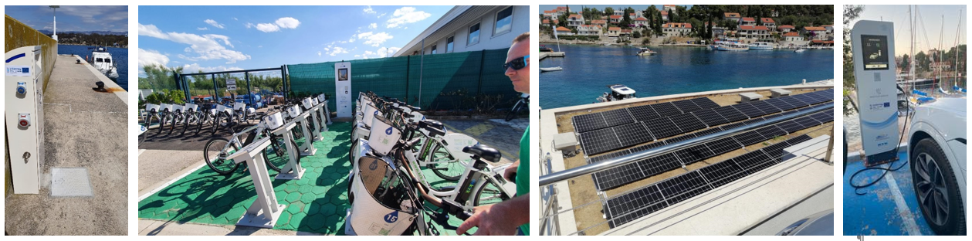
In parallel with these investments, the DEEP-SEA project developed an ICT application to enable end-users to map, access, book and pay the mobility services activated in each pilot marina. The application represents a unique web-portal for the promotion of the sustainable mobility offer through which services could be spread to further Adriatic locations. Finally, project partners elaborated a set of guidelines for the elaboration of intervention and investment plans related to mobility services, and contributed to the activation of a cross-border network, aimed to replicate the positive effects of sustainable mobility services kicked-off within the project.
If you wish to learn more about DEEP-SEA, join project partners in Trieste on 23rd November, from 9:00 to 13:30, at the Hotel Savoia Excelsior Palace (Agenda attached).
Registrations at the following link: shorturl.at/jFTW1
Follow DEEP-SEA through its website and social media:
https://www.italy-croatia.eu/web/deep-sea
https://www.facebook.com/people/Interreg-Italy-Croatia-Deep-Sea/100068843065513/
https://twitter.com/DeepSeaInterreg
https://www.linkedin.com/company/deep-sea-interreg-italy-croatia-programme

